Community of Interest Mapping Tool

WHAT is a Community of Interest?
Those with common social or economic interests that should be included within a single district for effective, fair representation.

WHY do they matter?
Communities of interest must be considered when deciding how to draw new district boundaries.

WHO needs to participate?
Communities are best described by those with first‐hand knowledge. We want to hear about your community; you know it best!

WHEN should I respond?
Turn in by January 31st for consideration in the draft maps.
31

HOW do I submit information about by community?
Email Drop off or mail
redistricting@cityoflivermore.net 1052 S. Livermore Ave
Livermore, CA 94550

WHERE can I get more information?
For more information visit our website at https://drawlivermore.org/
or call 925-960-4200.
1) Name your Community: ____________________________________________________________________________

2) Draw your Community on the Map:
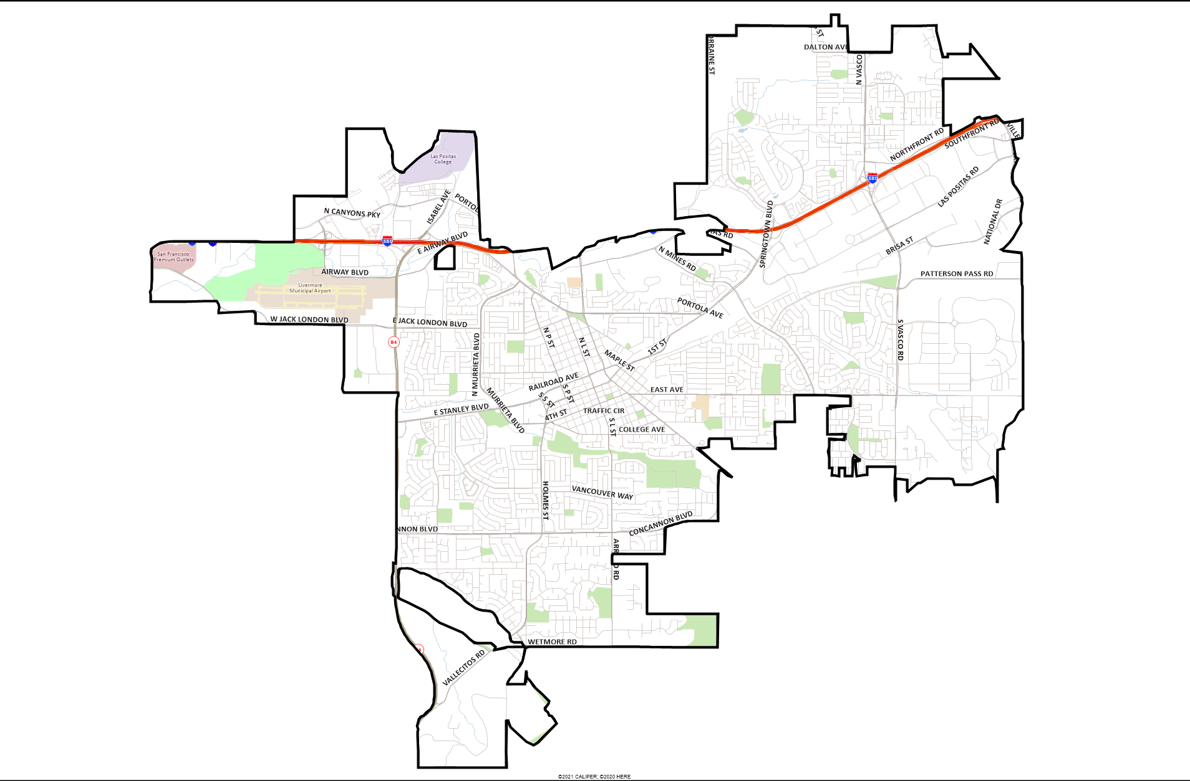

3) Describe your Community (Specific boundaries. What makes it a community? Why should it be kept together?):

_________________________________________________________________________________________________

_________________________________________________________________________________________________

_________________________________________________________________________________________________

_________________________________________________________________________________________________

4) Tell us about Yourself (optional):

Name: _______________________________ Email: _________________________________

Email to redistricting@cityoflivermore.net or drop off or mail to 1052 S. Livermore Ave; Livermore, CA 94550 by January 31st for consideration in the draft maps.

